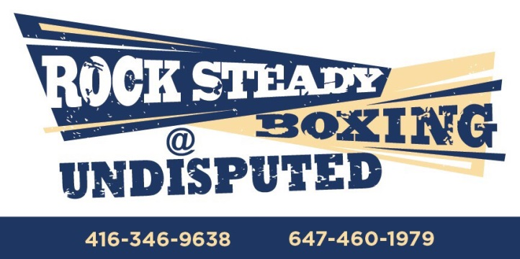
Waiver and Release of Liability
Rock Steady Boxing, Inc. (hereinafter, “RSB”):

- I understand the nature of Rock Steady Boxing, Inc.’s activities, and my physical condition and capabilities, and I believe that I am physically capable of participating in such activity. I further acknowledge that I am aware that the activity may be conducted in facilities open to the public or members of the public and/or employees of another corporate entity or entities, during the activity. I further agree and warrant that any time, if I believe any condition to be unsafe, I reserve the right, without penalty, financial or otherwise, to immediately discontinue further participation in the activity and bring such condition to the attention of the management of RSB.
- I FULLY UNDERSTAND that (a) the activities of RSB involve risks and dangers of SERIOUS BODILY INJURY, including permanent disability, paralysis and death (“Risks”); (b) these Risks and dangers may be caused by me or by the actions or inactions of others participating in the activity, the conditions under which the activity takes place, or THE NEGLIGENCE OF THE “RELEASEES” NAMES BELOW; (c) there may be other risks and social and economic losses either known to me or not readily foreseeable at this time, and I FULLY ACCEPT AND ASSUME ALL SUCH RISKS AND ALL RESPONSIBILITY FOR LOSSES, COSTS, AND DAMAGES incurred as a result of my participation in these activities.
- I HEREBY RELEASE, DISCHARGE, COVENANT NOT TO SUE, AND AGREE TO INDEMNIFY AND SAVE AND HOLD HARMLESS RSB, its clubs and their respective administrators, directors, agents, officers, volunteers, and employees, other participants, any sponsors, advertisers, and if applicable, owners and lessors of premises on which the activities take place (each considered one of the “Releasees” herein) from all liability, claims, demands, losses, or damages on my account caused or alleged to be caused in whole or in part by the negligence of the “Releasees” or otherwise, including negligent rescue operations and further agree that if, despite this release, I or anyone on my behalf makes a claim against any of the Releasees, I will be responsible for the payment to any or all of the releasees harmed by such assertion of a waived claim , or any expenses arising from my assertion of waived claims or causes of action, including but not limited to reasonable attorney fees and court costs.
- I certify that I have had no injuries to my hands, whether fractures, broken bones, or otherwise, within the three months preceding the dates of completion of this entry form, and have no injuries to the head, concussion, headaches or fainting spells, and should I experience any of these injuries and/or conditions in the future, I will immediately notify the officials of these events and/or conditions, and immediately cease my participation in said events and activities.
- I hereby further agree that this agreement may not be modified orally, and a waiver of any provision shall not be construed as a modification of any other provision herein or as consent to any subsequent waiver or modification. Every term and provision of this agreement is intended to be severable, if any one or more provision is found to be unenforceable or invalid, said provision shall not affect the other terms and provision, which shall remain binding and enforceable.

_________________________________ Date _____/_____/_____
Printed Name of Applicant

_________________________________
Signature of Applicant

